**Teaching Sound Editing with Audacity and Makey Makey Instructions**

1. In the Monster Makey git hub head to the resources tab.

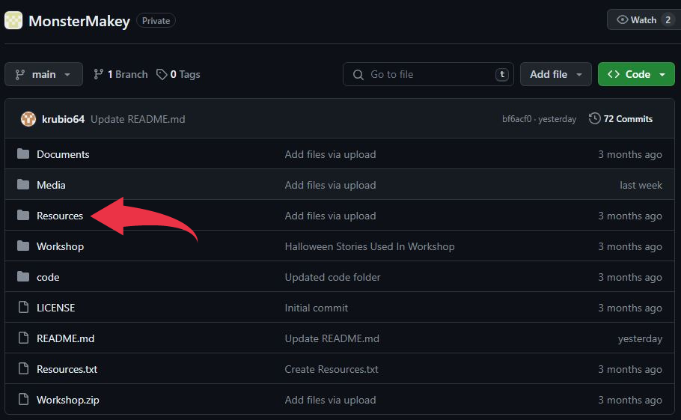

1. Download the story files containing the horror story, a scratch file, and a group of edited sounds for the corresponding story.
2. Set up as many computers with a provided story, a Makey Makey controller, and make sure the computers have their corresponding edited sound files and scratch files.

Instructions for Makey Makey setup

* 1. Have a Makey Makey set and at least 2 different playdough colors per set.

* 1. Separate the playdough so that one color is full, while the other is split into 6 pieces.

* 1. Take one of the pins found in you Makey Makey set and connect it to the big piece of playdough. (Make sure this connects to the Earth hole shown below)

* 1. For the rest of the pins, connect them to the 6 smaller pieces and to the provided inputs being (up, down, left, right, and space)

* 1. Finally connect your Makey Makey devices to a computer via a USB wire.

1. Head to <https://scratch.mit.edu>
2. In scratch click on create in the top.

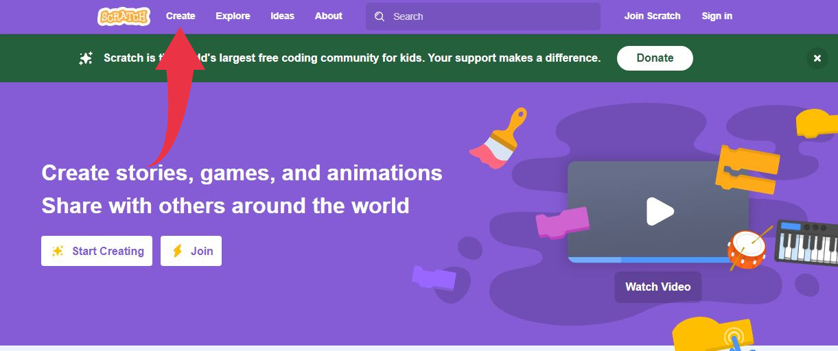

1. Once in the create head to file, then click “load from your computer”.
2. Find the .sb3 file that you downloaded from GitHub that corresponds to the story.

1. Once everything is set up, let students play the sounds along their horror story along via Makey Makey.
2. Now it’s time to move onto Audacity, so have the students open up Audacity.
3. Click the File tab on the top left corner of the screen and import the previously downloaded .mp3 files.

1. At the top left of the screen, you can play/pause the sound(s)

12. To select certain tracks to not play, you can mute the track (press the mute button under the name of the track)

15. To only play a certain track, you can solo the track (press the solo button next to the mute button)

16. By left-clicking and holding then releasing to either the left or the right (to select the whole track, click the blank part of the blueish-gray box)

17. Select the first half of the scream

18. Split the section, then delete the second half

19. Then copy and paste the selection

20. Click on the second section of the track and go to effect, special, and select reverse

21. Select the whole track, then go to the edit tab, audio clips, join

23. Go to File, export, then export multiple

25. Choose .mp3, as the "spilt files on"

26. Name Files using track names

37. Now click the sound icon

38. Click the upload button and upload your sound effect

39. Then use Makey Makey again with the new sound that was edited.